Vieta’s Law

Notes:
- For finding useful information from the coefficients of polynomials
- Easily derived from multiplying the linear factors of the polynomial
  - If r is a root then f(x) is divisible by (x-r)
  - If f(x) has n degrees then it has n complex roots
- For quadratic multiply (x-r1)(x-r2) and regroup to see coefficients, can also use quadratic formula
- Quadratic: ax² + bx +c
  - r₁ + r₂ = -b/a
  - r₁r₂ = c/a
  - What are the sum and product of the roots of the quadratic equation
x² - 12x + 24 = 0 ?
  - What are the sum and product of the roots of the quadratic equation
3x² + 15x - 18 = 0 ?
- For cubic just multiply out (x-r₁)(x-r₂)(x-r₃) where the r_{a} are roots of the cubic and look at the coefficients
- Cubic : ax³ + bx² + cx +d
  - r₁+r₂+r₃ = -b/a
  - r₁r₂ +r₂r₃ +r₁r₃ = c/a
  - r₁r₂r₃ = -d/a
  - What are single sum, double sum, and product of the roots of the cubic equation
x³ + 4x² − 10x − 18 = 0 ?
- Higher Degree:
  - Same idea, for single sums, -b/a
  - For two roots multiplied together sums, c/a
  - Etc.
  - Alternate plus and minus
- You can also manipulate the sums/products:
- Ex. 1:
If α and β are the roots of the equation 2x² - 7x + 4 = 0, what is the value of 1/α + 1/β ?
- Ex. 2:
If g and h are the roots of the equation: x² - 6x + 6 = 0
What is the value of: g² + h² ?

Simon’s Favorite Factoring Trick

Notes:
- Useful algebraic manipulation technique
- General representation:
xy + ax + by = d
x(y + a) + b(y + a) = d + ab
(x + b)(y + a) = d + ab

- Ex. 1:
Factor 4xy + 6x + 10y.

Practice Questions

2000 AMC 12 Problems/Problem 6
Two different prime numbers between and are chosen. When their sum is subtracted from their product, which of the following numbers could be obtained?

1987 AIME Problems/Problem 5
Find 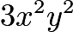 if and are integers such that .

2011 JBMO Problems/Problem 2
Find all primes such that there exist positive integers that satisfy 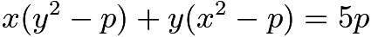.

2005 AMC 12A Problems/Problem 9
There are two values of for which the equation has only one solution for . What is the sum of these values of ?

1952 AHSME Problems/Problem 23
If 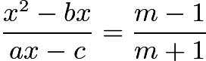 has roots which are numerically equal but of opposite signs, the value of must be:

2008 AIME II Problems/Problem 7
Let , , and be the three roots of the equationFind .

2009 AMC 12A Problems/Problem 16
A circle with center is tangent to the positive and -axes and externally tangent to the circle centered at 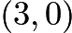 with radius . What is the sum of all possible radii of the circle with center ?

2009 AMC 12A Problems/Problem 17
Let 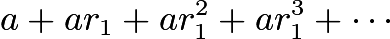 and 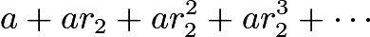 be two different infinite geometric series of positive numbers with the same first term. The sum of the first series is , and the sum of the second series is . What is ?

2007 Alabama ARML TST Problems/Problem 12
If and 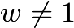, then evaluate
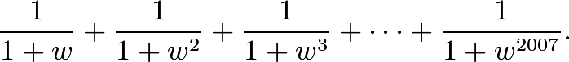
Express your answer as a fraction in lowest terms.

